ĐỀ THI TIẾNG ANH Mã đề: 10
Trình độ A2
Họ và tên thí sinh: ……………..……………………………………………………….…………………………………………………………
Số báo danh: ……………..…………………………………………...……. Phòng thi số: …………………………….……………

PAPER TWO LISTENING (Approximately 15 minutes)
PART 1: Questions 1 – 5
There are five questions in this part. For each question there are three answer choices and a short recording. Tick (√) the correct answer. You will hear the piece twice.
Example: How many people were at the meeting?
A. 3 B. 13 √ C. 30
1. What’s Steve doing now?
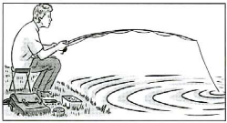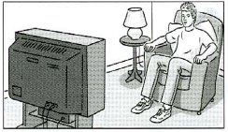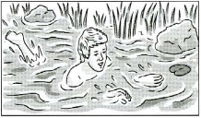
A □ B □ C □
2. How are they going to get to the countryside?
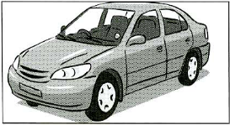 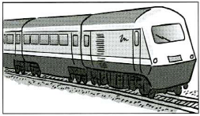 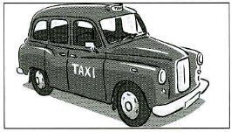 A □ B □ C □
3. What will the woman do tonight?
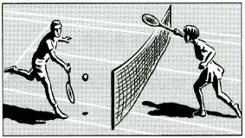 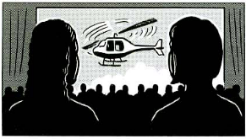 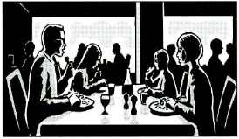 A □ B □ C □
4. Where is the cat now?
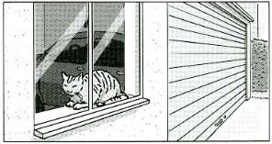 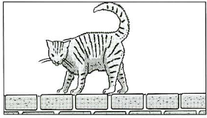 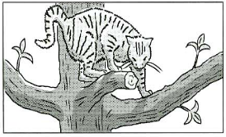 A □ B □ C □
5. What job does Mary’s brother do?
 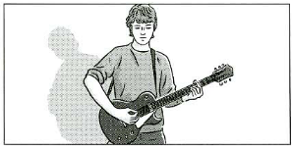  A □ B □ C □
PART 2: Questions 6-10
Listen to Teresa talking to Paul about presents for his family. What is she going to buy for each person?
For questions 6-10, write a letter A-H next to each person. You will hear the conversation twice.
EXAMPLE | ANSWER
0 Kevin | A
PEOPLE |  | PRESENTS
6 JonCFBGD  7 Ann  8 Mother  9 Father  10 Paul |  | A book  B cassette  C football  D meal  E shirt  F theatre tickets  G tie  H video

PART 3: Questions 11-15
Listen to Diane talking to a friend about a trip to London.
For questions 11-15, tick (√) A, B, or C. You will hear the conversation twice.
Example: 0. Danie went to London yesterday
A. morning
B. afternoon
C. evening
11. Diane went to London by
A. car
B. bus
C. underground
12. Diane and her friends ate
A. Mexican food
B. Chinese food
C. Spanish food
13. Diane says the restaurant was
A. full
B. expensive
C. quiet
14. After the meal, Diane and her friends
A. sat and talked
B. saw a film
C. walked by the water
15. During Diane’s trip to London,
A. it rained
B. it snowed
C. it was windy

